**Functional Test - Do exploration testing for the basic functions of owasp juice app.**

**Bugs**

**Bug id:** S.B-000001

**Title:** Products are not getting updated in time resulting in two users buying the same product which only has 1 item available

**Priority:** P1

**Browser:** Chrome 131.0.6779.86

**Link:** <https://juice-shop.herokuapp.com/#/>

**Reproduction steps:**

1. Go to the link <https://juice-shop.herokuapp.com/#/>
2. Login with user a
3. Login with user b
4. Follow the following steps for both users
   1. Find a product which is marked as “Only 1 left”
   2. Select the same product for both users and click Add to Basket
   3. Checkout and Provide address and Payment details
   4. Complete the purchase

**Actual Result:**

Both users are able to purchase a product which only had Quantity 1 available

**Expected Result:**

When a user has added a product in his basket, the quantity should be put on hold for this user for some decided time to avoid multiple users buying the same product which is low in availability.

**Bug id:** S.B-000002

**Title:** GDPR issue – user data is still available even after the user requested to erase data

**Priority:** P1

**Browser:** Chrome 131.0.6779.86

**Link:**

**Reproduction steps:**

1. Go to the link <https://juice-shop.herokuapp.com/#/>
2. Login to the application with a user who has saved addresses and purchased products in past
3. User Navigates to the Request Data Erasure page <https://juice-shop.herokuapp.com/dataerasure>
4. Provide required information and click DELETE USER DATA button
5. User is logged out
6. Login in again with the same user
7. Go to My Saved Addresses

**Actual Result:**

Saved addresses still contain the data added earlier

**Expected Result:**

All user related data should be deleted if the user has requested to erase his/her data

**Bug id:** S.B-000003

**Title:** Incorrect balance is getting appeared in Wallet balance - Checkout screen

**Priority:** P1

**Browser:** Chrome 131.0.6779.86

**Link:** https://juice-shop.herokuapp.com/#/

**Reproduction steps:**

1. Sign in to application
2. Navigate to Link mentioned above
3. Add items to basket and Go to checkout screen
4. Observe in wallet balance it says 0
5. Create multiple orders where you get bonus on placing order
6. Now go to checkout screen and view wallet balance
7. Now come to order history screen and calculate the total bonus from different orders i.e approx 2300

**Actual Result:**

The number of bonus you got from orders is higher than the value added to your wallet.

**Expected Result:**

Wallet balance should be matched with earned bonus

**Screenshot:**





**Bug id:** S.B-000004

**Title:** Incorrect count displays on Your Basket icon when user navigates to User Profile and then comes back to the home page

**Priority:** P2

**Browser:** Chrome 131.0.6779.86

**Link:** https://juice-shop.herokuapp.com/#/

**Reproduction steps:**

1. Go to the link <https://juice-shop.herokuapp.com/#/>
2. Login to the application
3. Click add to basket button for two products
4. Observe on top right there is Button named Your Basket – it shows 2 i.e. is the number of items selected in basket
5. Now click on Profile, Click Username – user will navigate to <https://juice-shop.herokuapp.com/profile>
6. Click on Back button on top left of the page
7. Observe on top right there is Button named Your Basket – it shows 0
8. Now click on Add to Basket on another product – user will see 3 in Your Basket button

**Actual Result:**

Your Basket button shows incorrect count (step 7)

**Expected Result:**

The count on Your Basket button should always be correct and updated

**Screenshot:**

**Bug id:** S.B-000005

**Title:** User Profile page: Click on Upload Picture or Link Page buttons without selecting a picture is taking user to an error page

**Priority:** P2

**Browser:** Chrome 131.0.6779.86

**Link:** https://juice-shop.herokuapp.com/profile

**Reproduction steps:**

1. Go to the link <https://juice-shop.herokuapp.com/#/>
2. Login to the application
3. Go to the User Profile page: <https://juice-shop.herokuapp.com/profile>
4. Click on Upload Picture
5. Repeat steps 3 and 4 for Link Image button

**Actual Result:**

Application Error

**Expected Result:**

Users should be prompted to select a file on clicking Upload Picture or Link Image buttons when no data already selected

**Screenshot:**

**Bug id:** S.B-000006

**Title:** Upload picture should have a size limit validation and image type validation – It goes to error page for invalid file type

**Priority:** P2

**Browser:** Chrome 131.0.6779.86

**Link:** https://juice-shop.herokuapp.com/profile

**Reproduction steps:**

1. Go to the link <https://juice-shop.herokuapp.com/#/>
2. Login to the application
3. Go to the link <https://juice-shop.herokuapp.com/profile>
4. Select a file by clicking the Choose File button – select PDF
5. Click Upload Picture

**Actual Result:**

User is navigated to error page

**Expected Result:**

Uploading picture should be validated for correct formats

**Screenshot:**

**Bug id:** S.B-000007

**Title:** User Registration:Password requirement is not adequate; it accepts any string with 5 or more characters

**Priority:** P2

**Browser:** Chrome 131.0.6779.86

**Link:** https://juice-shop.herokuapp.com/#/register

**Reproduction steps:**

1. Go to the link <https://juice-shop.herokuapp.com/#/>
2. From Top right menu click on Account
3. Click Login
4. Click on Not yet a customer? Hyperlink
5. Provide details and give password as ‘teste’

**Actual Result:**

Weak password is allowed

**Expected Result:**

Password restrictions given in Show Password Advice toggle should be mandated

**Bug Id** S.B-00008

**Title:** User is not getting error message for password mismatch on click of register button from registration page.

**Priority:** P2

**Browser:** Chrome 131.0.6779.86

**Link:** https://juice-shop.herokuapp.com/#/register

**Reproduction steps:**

1. Navigate to Link mentioned above
2. Add email address
3. Create a password
4. Enter same password in repeat password
5. Update the password by adding 1 or 2
6. Click on register

**Actual Result:** Repeat password is not as same as password, and there is no error message for a user.

**Expected Result:** It should prompt user with message which says repeat password is not matched

**Screenshot:**

**Bug Id** S.B-00009

**Title:** Show price of items added as per quantity instead of actual price of item

**Priority:** P2

**Browser:** Chrome 131.0.6779.86

**Link:** https://juice-shop.herokuapp.com/#/

**Reproduction steps:**

1. Login to the application
2. Navigate to Link mentioned above
3. Add item to the basket
4. Click on basket to view item in basket
5. Update quantity of item added in basket

**Actual Result:**

It shows price of item as a single quantity and getting added in total price

**Expected Result:**

On update of quantity, price per item should also be updated depending on the number of quantity added.

**Screenshot:**

**Bug Id** S.B-000010

**Title:** Saved address is removed from the checkout screen on logout from application

**Priority:** P2

**Browser:** Chrome 131.0.6779.86

**Link:** https://juice-shop.herokuapp.com/#/

**Reproduction steps:**

1. Navigate to Link mentioned above
2. Place an order and add address on checkout
3. Now place another order – You should be able to view the saved address
4. Sign out from the web page
5. Sign in again with the same user
6. Add item to basket and navigate to checkout page

**Actual Result:**

Saved address is no more visible on checkout screen

**Expected Result:**

User should be able to view the saved address in checkout screen

**Bug Id** S.B-000011

**Title:** Saved card information is removed from checkout screen on logout from application

**Priority:** P2

**Browser:** Chrome 131.0.6779.86

**Link:** https://juice-shop.herokuapp.com/#/

**Reproduction steps:**

1. Navigate to Link mentioned above
2. Place an order and add card information on checkout
3. Now place another order – You should be able to view the saved card
4. Sign out from the web page
5. Sign in again with the same user
6. Add item to basket and navigate to checkout page

**Actual Result:**

Saved card is no more visible on checkout screen

**Expected Result:**

User should be able to view the saved card in checkout screen

**Bug Id** S.B-000012

**Title:** Updating language should displayProduct name, product description and reviews in selected language

**Priority:** P2

**Browser:** Chrome 131.0.6779.86

**Link:** https://juice-shop.herokuapp.com/#/

**Reproduction steps:**

1. Navigate to Link mentioned above
2. Change the language of application to Francais or any other than English

**Actual Result:**

Product name, product description and reviews are not getting updated on new language. It only shows in English

**Expected Result:**

Product name, product description and reviews should be displayed in selected language

**Screenshot:**

**Bug id:** S.B-000013

**Title:** Photo wall first shows no photo message and after a couple of seconds it shows all available photos

**Priority: P3 - Low**

**Browser:** Chrome 131.0.6779.86

**Link:** https://juice-shop.herokuapp.com/#/photo-wall

**Reproduction steps:**

1. Go to the link <https://juice-shop.herokuapp.com/#/>
2. Click on top left menu hamburger menu
3. Click on Photo Wall

**Actual Result**

Photo wall first shows no photo message and then after a couple of seconds it show the available photos (this is more visible when images are not cached)

**Expected Result:**

Photo wall should show photos on initial load

**Screenshot:**

**Bug id:** S.B-000014

**Title:** Afterchanging password from Forgot password, user should be navigated to the login page

**Priority:** P3

**Browser:** Chrome 131.0.6779.86

**Link:** https://juice-shop.herokuapp.com/#/forgot-password

**Reproduction steps:**

1. Go to the link <https://juice-shop.herokuapp.com/#/forgot-password>
2. Change password from the Forgot Password page after adding all details

**Actual Result:**

User remains on the Forgot password page

**Expected Result:**

User should navigate to Login page after password is changed. There is no navigation available to move to Login page on Forgot Password page

**Screenshot:**

**Bug id:** S.B-000015

**Title:** On Request Recycling Box, user cannot submit a request if there is no address already saved in My Saved Addresses

**Priority:** P3

**Browser:** Chrome 131.0.6779.86

**Link:** https://juice-shop.herokuapp.com/#/recycle

**Reproduction steps:**

1. Login to the application
2. Go to the link <https://juice-shop.herokuapp.com/#/recycle>
3. Select Quantity as 10

**Actual Result:**

Submit button is not enabled

**Expected Result:**

If user does not have any Saved Addresses, there should be a proper messaging or there should a way to add a address

**Screenshot:**

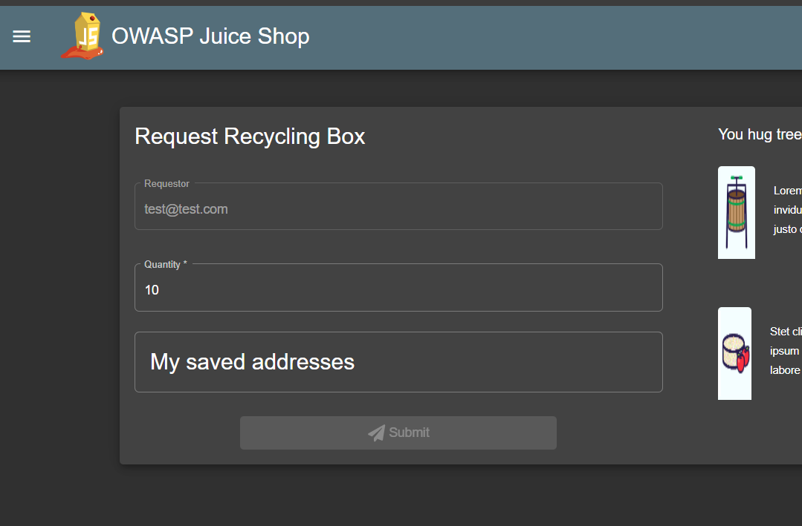

**Bug Id** S.B-000016

**Title:** Adding same item for multiple times displays total price without restriction of decimal values in checkout screen

**Priority:** P3

**Browser:** Chrome 131.0.6779.86

**Link:** https://juice-shop.herokuapp.com/#/

**Reproduction steps:**

1. Navigate to Link mentioned above
2. Add item to cart having price 2.99 (set qty to 5)
3. Go to Checkout screen
4. Add different items to cart having different price say ‘0.89’
5. Add item to cart having price 2.99 (3 in qty)
6. Go to checkout screen

**Actual Result:**

**Step2:** In checkout screen total price displays price without any decimal restriction

**Step 6:** In checkout screen total price displays price without any decimal restriction

**Expected Result:**

It should show total price only having 2 number after decimal **i.e. ’14.95’**

**Screenshot:**

**Bug Id** S.B-000017

**Title:** Getting multiple toast message on track order screen after placing order successfully

**Priority:** P3

**Browser:** Chrome 131.0.6779.86

**Link:** https://juice-shop.herokuapp.com/#/

**Reproduction steps:**

1. Navigate to Link mentioned above
2. Add items to basket
3. Navigate to checkout screen
4. Click on checkout
5. Add address, card information and complete the order
6. Click on track order screen

**Actual Result:**

User is getting multiple toast messages on top which is not linked with the current session

**Expected Result:**

User shouldn’t get toast messages which are not linked to the track order screen

**Screenshot:**

**Bug Id** S.B-000018

**Title:** Pagination is not getting persisted on moving back from checkout screen to All product page

**Priority:** P3

**Browser:** Chrome 131.0.6779.86

**Link:** https://juice-shop.herokuapp.com/#/

**Reproduction steps:**

1. Navigate to Link mentioned above
2. From all product page set pagination to page for 24 or 36
3. Add item to basket
4. Navigate back to All product page

**Actual Result:**

Pagination is not getting persisted

**Expected Result:**

User should be able to view 24 or 36 items on page

**Bug Id** S.B-000019

**Title:** Password and repeat password field for number of characters long is not showing correctly.

**Priority:** P3

**Browser:** Chrome 131.0.6779.86

**Link:** https://juice-shop.herokuapp.com/#/register

**Reproduction steps:**

1. Navigate to Link mentioned above

**Actual Result:**

In the password field it says password must be 5-40 characters long but on the right side it only shows 0/20

**Expected Result:**

Password field must say 0/40 for password field as well

**Screenshot:**

**Bug Id** S.B-000020

**Title:** Show all products on clicking of cancel button from search box

**Priority:** P3

**Browser:** Chrome 131.0.6779.86

**Link:** https://juice-shop.herokuapp.com/#/

**Reproduction steps:**

1. Navigate to Link mentioned above
2. Click on search icon
3. Type apple and search for it
4. Now remove apple by clicking close icon

**Actual Result:**

Product section still show search result with ‘Apple’ and list only items contains word ‘apple’

**Expected Result:**

User should be able to view all products when hit close icon for search

**Screenshot:**

**Bug Id** S.B-00021

**Title:** Disable items which are sold out and make them to be not clickable

**Priority:** P3

**Browser:** Chrome 131.0.6779.86

**Link:** https://juice-shop.herokuapp.com/#/

**Reproduction steps:**

1. Navigate to Link mentioned above
2. Find an item which is soldout
3. Click on Add to basket

**Actual Result:**

Nothing happens on click of add to basket button

**Expected Result:**

Disable items which are sold out so that user cannot click it.

**Screenshot:**

**Bug Id** S.B-000022

**Title:** Size of icon used for products should be same so that Add to basket should be aligned properly in same line

**Priority:** P3

**Browser:** Chrome 131.0.6779.86

**Link:** https://juice-shop.herokuapp.com/#/

**Reproduction steps:**

1. Navigate to Link mentioned above

**Actual Result:**

For some of the products image is not of same size which is causing Add to basket button not gets aligned with div

**Expected Result:**

Keep size of the image consistent so that Add to basket button should be aligned in div

**Screenshot:**

